Pinecone Setup and Fallback Logic – Findings Summary
AI Travel Assistant for Accessible Aviation
Project: AI Travel Assistant for Accessible Aviation (Your Accessible Flight)
Prepared by: Aindrila Das Prapti (DEV)
Purpose
The purpose of this research is to understand Pinecone’s dashboard, vector-search concepts and API structure before Sprint development begins. The client confirmed that Pinecone is currently used as the chatbot’s primary retrieval layer because of its speed during airport testing. The client also stated that Groq or OpenAI is used as a fallback when Pinecone takes longer than 10 seconds or cannot return an answer
Pinecone Dashboard and Core Concepts
I created a test Pinecone index named yaf-learning-test using the llama-text-embed-v2 embedding model.
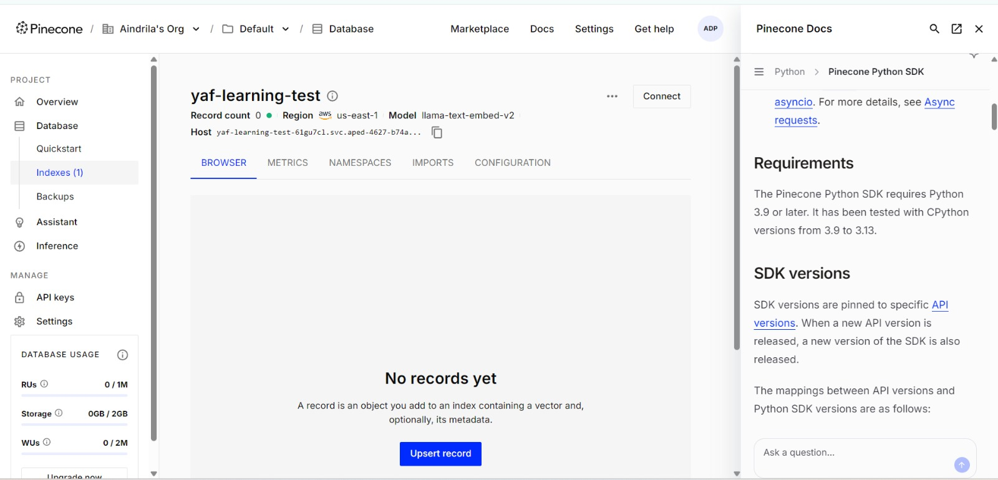
Figure 1. The yaf-learning-test index using the llama-text-embed-v2 embedding model.

I added three test records covering airport wheelchair assistance, aircraft cargo-door accessibility and wheelchair-battery safety. Each record contained a unique ID, text and category metadata.
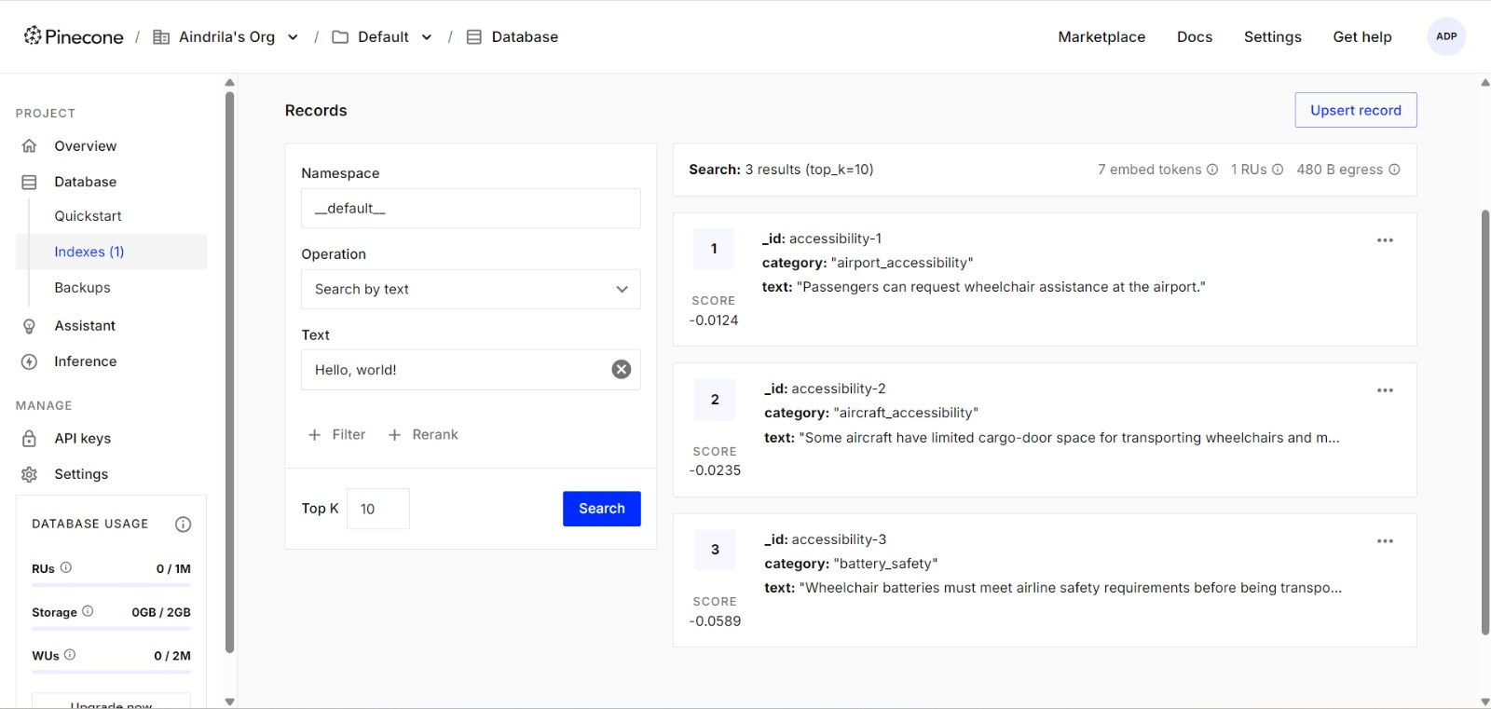
Figure 2. Test records containing unique IDs, accessibility text and category metadata.
I then tested semantic similarity search using the question, “Can I take my electric wheelchair battery on a plane?” Pinecone correctly ranked the battery-safety record first with a similarity score of 0.6022. This demonstrated that Pinecone retrieves information based on meaning rather than requiring an exact keyword match.
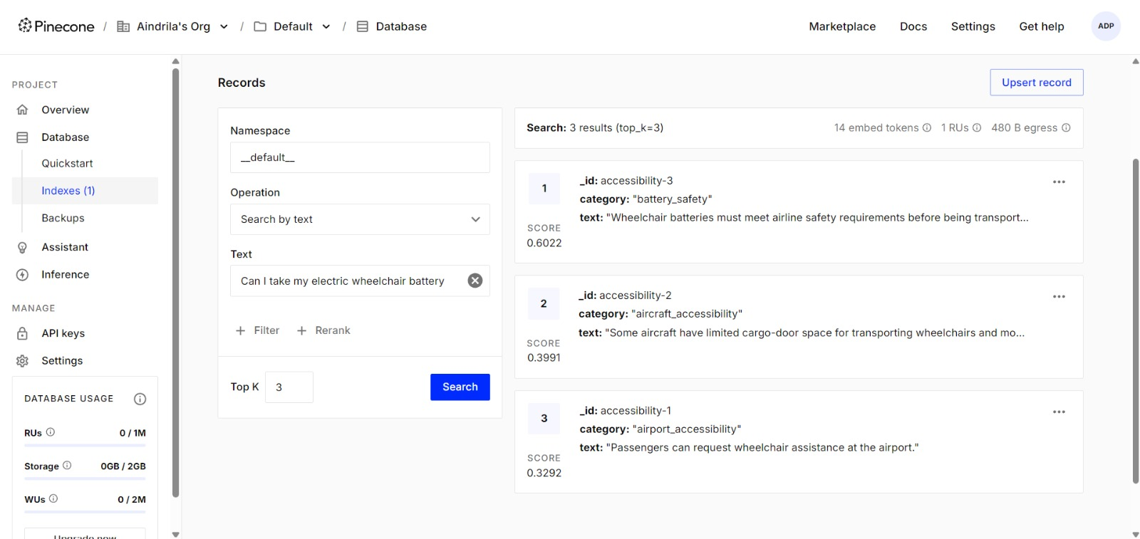
Figure 3. Pinecone ranked the battery-safety record first for a wheelchair-battery question.
An index is the searchable container for vector records. Embeddings are numerical representations of meaning, while similarity search compares the user’s query embedding with stored record embeddings. Metadata provides additional information that can be used to identify or filter records.

Pinecone API and Go Backend Connection
Based on the client’s email, the existing backend appears to be written in Go. This should be confirmed after repository access is provided. I selected Go in Pinecone’s connection instructions and identified the official Go SDK:
go get github.com/pinecone-io/go-pinecone/v4/pinecone
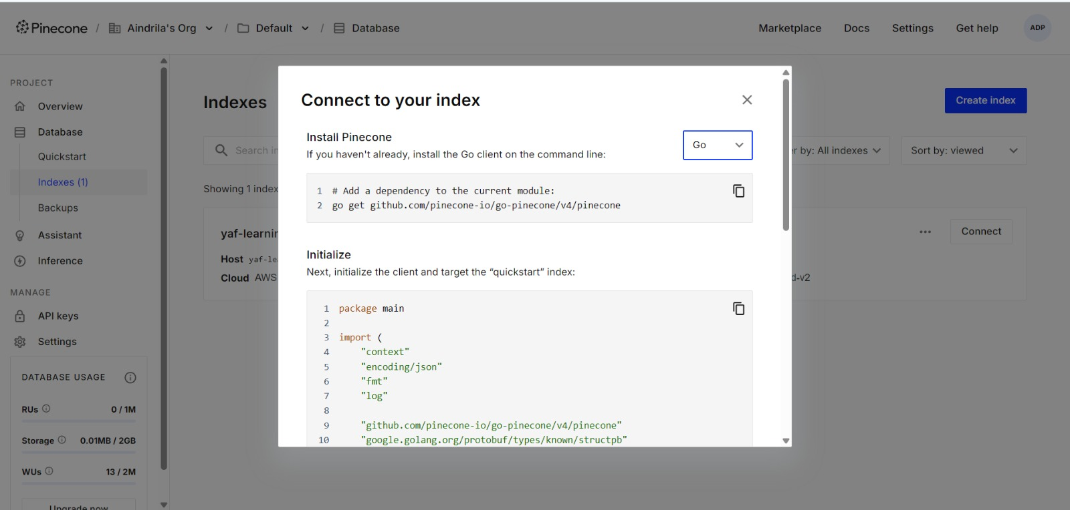
Figure 4. Pinecone’s Go SDK installation instructions
I reviewed how a Go application initialises a Pinecone client. The API key authenticates the application and allows it to communicate with the Pinecone project. I also observed that the connection code includes error handling in case the client cannot be created successfully.
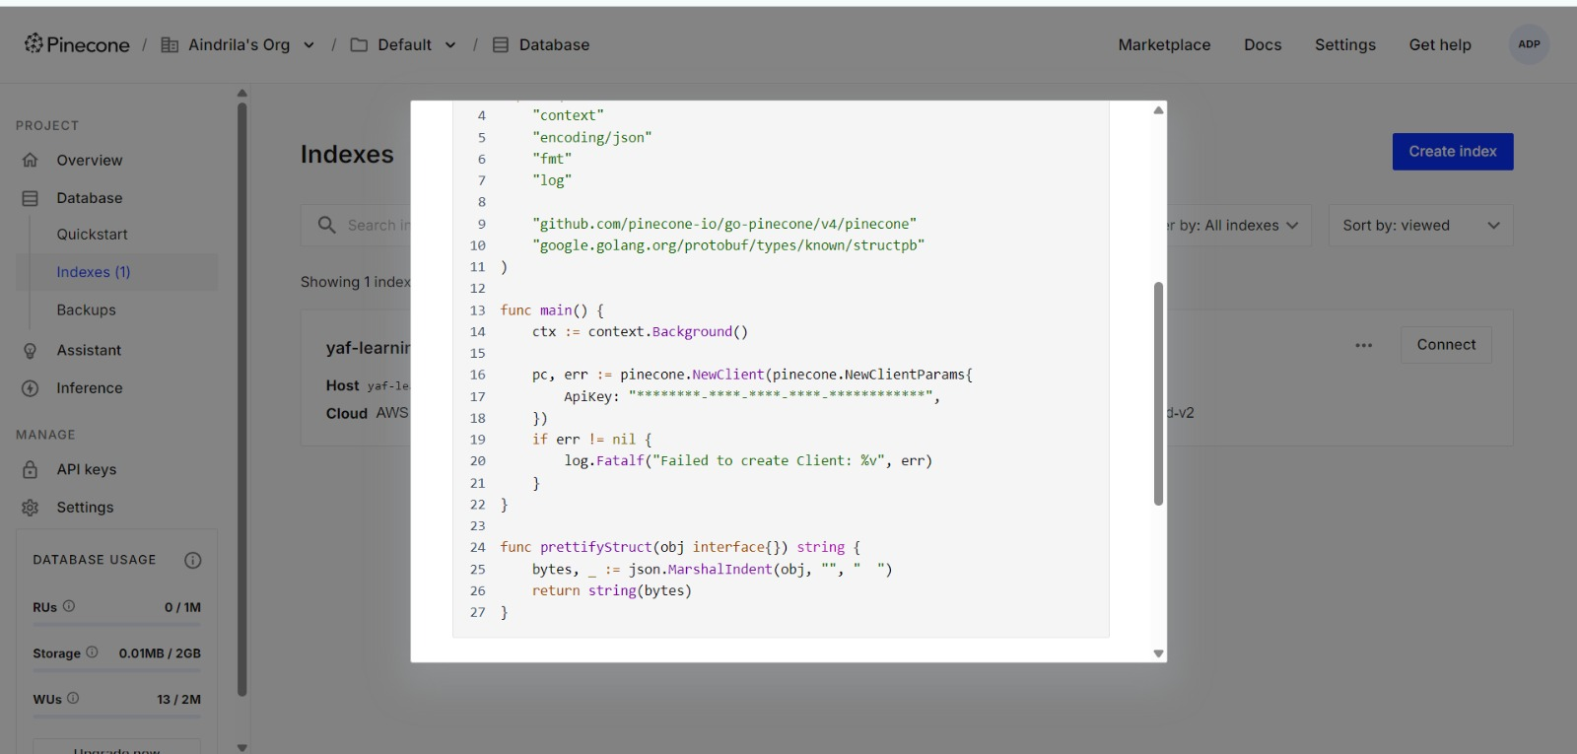
Figure 5. Go code for initialising the Pinecone client.
The API key shown during my review was masked. In the actual application, it should be stored securely in an environment variable and should never be hard-coded, committed to GitHub or shared publicly.
Reviewing API Queries and Results
I reviewed Pinecone’s latest Search with Text API documentation. A semantic-search request uses the following endpoint:
POST /records/namespaces/{namespace}/search
The request includes the namespace, the user’s query and a top_k value specifying the maximum number of matching records to return.
A successful response contains:
- hits containing the matching records
- _id containing each record’s unique identifier
- _score showing its similarity score
- fields containing the stored text and metadata
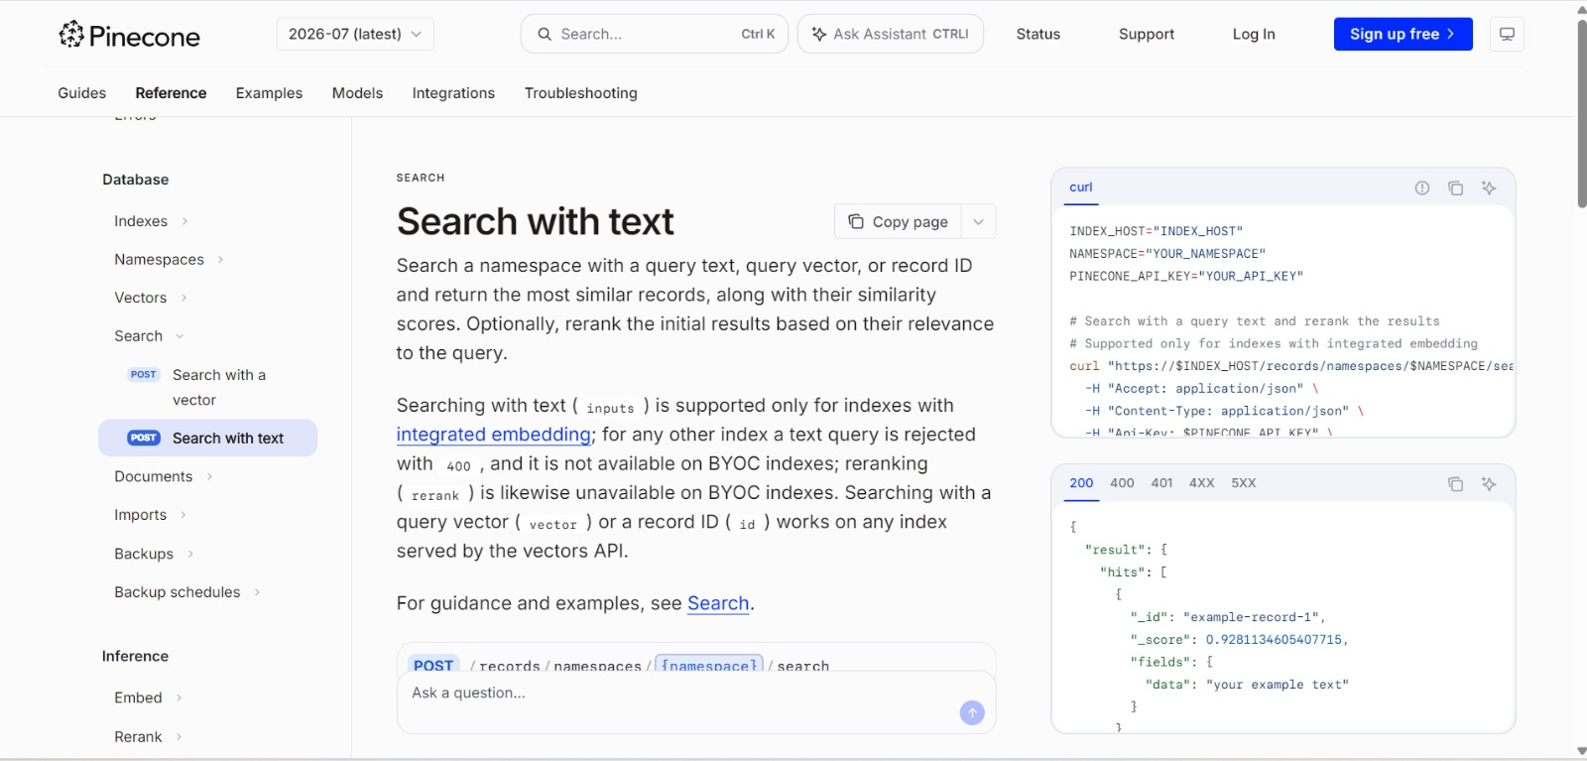
Figure 6. Pinecone Search API request and response structure.
I also reviewed the possible API responses. A 200 response indicates a successful request, while 400 indicates an invalid request and 401 indicates missing or invalid authentication. Other 4XX responses represent request-related errors, while 5XX responses indicate a server-side failure.
Groq/OpenAI Fallback Logic
I reviewed how the chatbot’s fallback process is expected to work. Pinecone is used as the primary retrieval layer because it can quickly find relevant information using semantic search.
The expected process is:
- The user submits a question to the chatbot.
- The backend sends the question to Pinecone and starts a 10-second timeout.
- If Pinecone returns a usable result within 10 seconds, that result is used to help generate the chatbot’s response.
- If Pinecone takes longer than 10 seconds, returns no relevant result, or encounters an error, the request is passed to Groq or OpenAI.
- The fallback provider generates a response, which is then returned to the user.
- If the fallback provider also fails, the chatbot should display a clear error message and ask the user to try again.
The following details still need to be confirmed by reviewing the client’s backend repository:
- Whether Groq or OpenAI is tried first.
- How the system determines whether a Pinecone result is usable.
- Whether Pinecone errors also trigger the fallback.
- What message is displayed if both Pinecone and the fallback provider fail.
- Whether the 10-second timeout is already implemented in the backend.
This review helped me understand the intended fallback design. However, its exact implementation will need to be confirmed after accessing and reviewing the client’s backend repository.
Relevant SDK
I reviewed the official Pinecone Go SDK because the client indicated that its backend project uses Go. The SDK can be installed using
go get github.com/pinecone-io/go-pinecone/v4/pinecone
It allows the backend to connect to a Pinecone index, add or update records, perform searches, and process the returned results. The client repository still needs to be reviewed to confirm the exact SDK version currently used.
I reviewed the usage allowances displayed in my Pinecone dashboard. The account currently provides up to 1 million Read Units (RUs), 2 million Write Units (WUs), and 2 GB of database storage. During my practical test, the index used 13 WUs and approximately 0.01 MB of storage. This indicates that the small test was well within the available allowances.
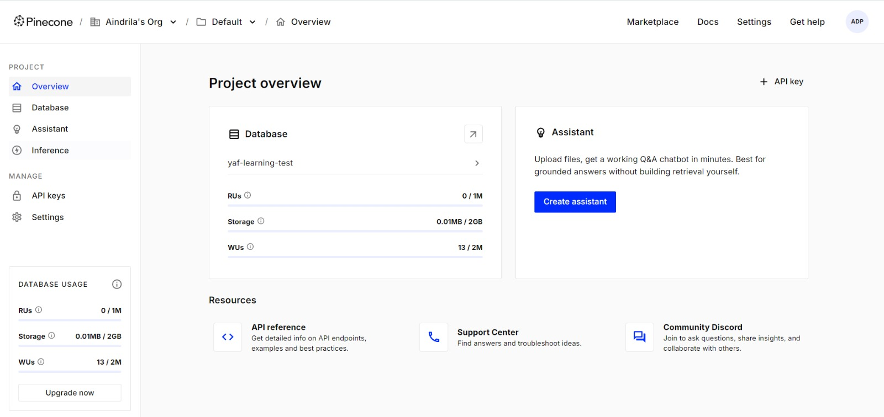Figure 7: Pinecone dashboard showing the current database usage and available allowances.
Starter Plan and Usage Allowances
I reviewed the available resources shown in my Pinecone dashboard. My test project currently uses the Starter plan, which provides the following monthly allowances:
- 1,000,000 Read Units (RUs)
- 2,000,000 Write Units (WUs)
- 5,000,000 embedding tokens per model
- 2 GB of database storage
My practical test used only 13 Write Units and approximately 0.01 MB of storage. Therefore, the three test records and semantic-search queries were well within the Starter plan’s available resources.

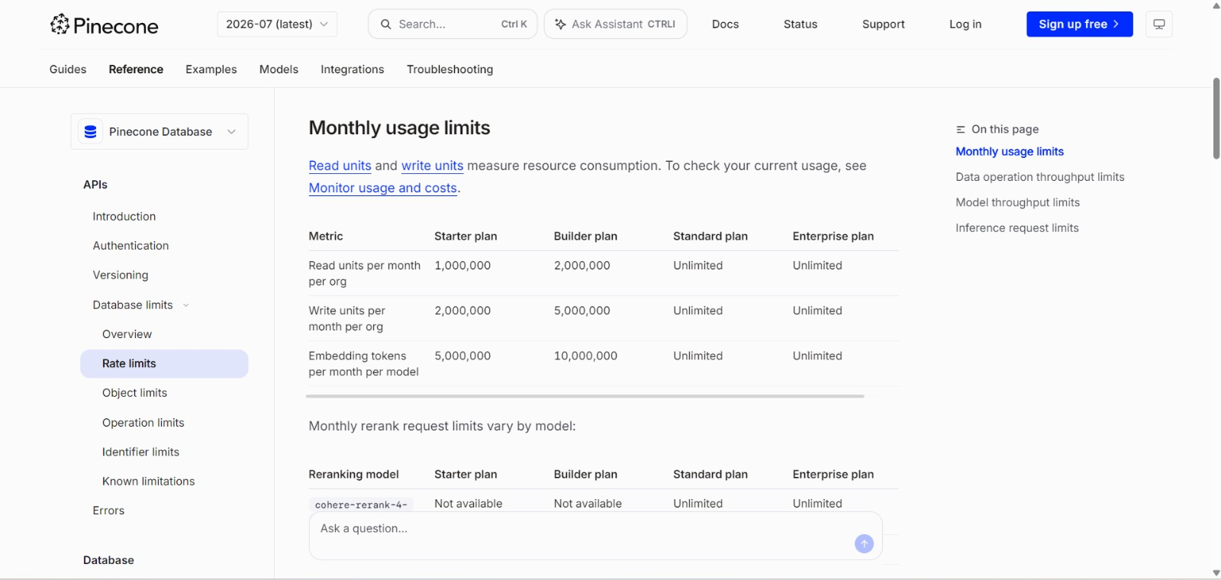
Figure 8: Pinecone documentation showing monthly Starter plan limits

Data-Operation Rate Limits
I also reviewed Pinecone’s data-operation throughput limits. The limits most relevant to the chatbot include:
- Up to 100 query requests per second per namespace
- Up to 100 upsert requests per second per namespace
- Up to 2,000 query Read Units per second per index
- Up to 50 MB of upsert data per second per namespace
Pinecone returns a 429 – TOO_MANY_REQUESTS error when an application exceeds an applicable rate or usage limit. Pinecone recommends pacing requests and implementing retry logic with exponential backoff when this occurs.
These limits should be considered when integrating Pinecone into the chatbot, particularly if many users submit questions simultaneously. However, they were more than sufficient for my small test.
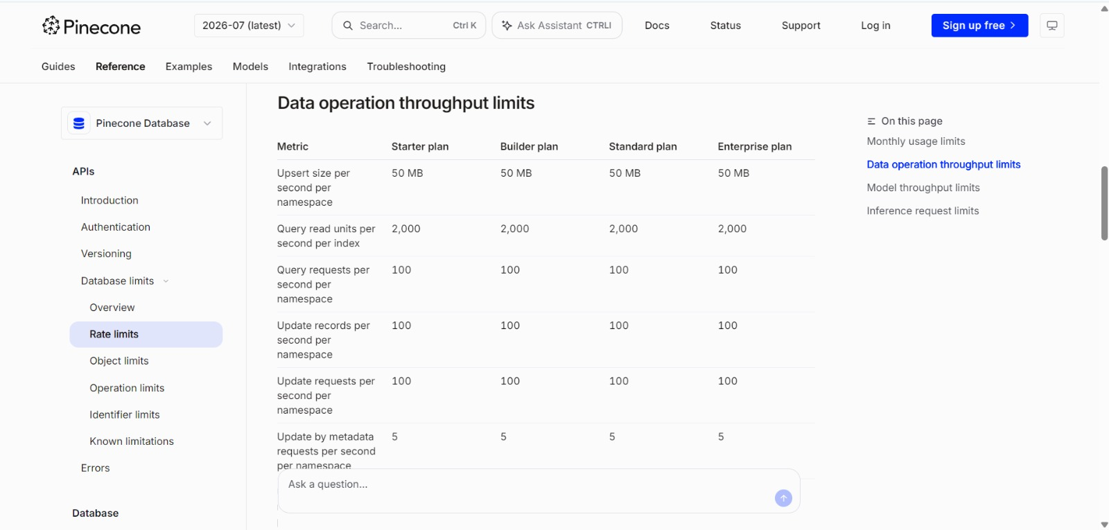
Figure 9: Pinecone documentation showing data-operation throughput limits.
Conclusion
I completed a practical review of Pinecone by creating a test index, adding accessibility-related records, and performing a semantic search. The test demonstrated how Pinecone converts text into embeddings and returns semantically relevant records with similarity scores. I also reviewed the Search API, Go SDK, Starter plan allowances, and relevant rate limits. Based on the client’s explanation, Pinecone is the chatbot’s primary retrieval layer, with Groq or OpenAI used when Pinecone takes longer than 10 seconds or cannot return an answer. The client’s backend repository must still be reviewed to confirm the exact connection settings, fallback-provider order, timeout implementation, and error-handling process.

Reference:
- Pinecone. (n.d.). Create an index. Retrieved September 6, 2026, from https://docs.pinecone.io/guides/index-data/create-an-index
- Pinecone. (n.d.). Semantic search. Retrieved September 6, 2026, from https://docs.pinecone.io/guides/search/semantic-search
- Pinecone. (n.d.). Search with text. Retrieved September 6, 2026, from https://docs.pinecone.io/reference/api/2025-01/data-plane/search_records
- Pinecone. (n.d.). Pinecone Go SDK. Retrieved September 6, 2026, from https://docs.pinecone.io/reference/sdks/go/overview
- Pinecone. (n.d.). Pinecone Database limits overview. Retrieved September 6, 2026, from https://docs.pinecone.io/reference/api/database-limits

